

**Department of  
Social Development**

**Applicant Guideline for completing the application form**

**September 2021**

Contents

Key terms and acronyms 3

1. Introduction 4

Purpose and scope of the Guidelines 4

2. General Guidelines 5

Structure of the Application Form 6

3. Instructions on completing the application form 7

Part A – RFP Details 7

Part B - NPO or Other Entity Details 8

Part C – Plan for Project, Programme or Other Intervention 14

Part D – Forms and Declarations 20

# Introduction

## Purpose and scope of the Guidelines

The purpose of these guidelines is to provide clarity and guidance on the requirements of the application form.

These guidelines should be used by organisations (e.g. NPOs) completing the application form for funding from the Department of Social Development for community development services. The information requested in the application form is essential to DSD to make decisions regarding the selection of service providers and the allocation of funds. Therefore, accurate and full completion of the application is necessary for fair adjudication of the applications.

We would encourage the person completing the form, to read through the guidelines before starting with the application form. Allow for sufficient time before the deadline to ensure that detailed and accurate information is provided. There are a number of supporting documents which need to be submitted together with the application form. Some of these documents may take some time to gather.

# General Guidelines

* **Before** completing the application form, ensure that:
  + Your organisation is eligible to apply for the funding by checking Part C of the RFP – Evaluation Criteria.
  + Ensure that the service you provide is one of the services for which DSD is requesting applications. The list of services is available in Part B of the RFP.
  + Ensure that you go through the application form well in advance of their due date. There are a number of requirements which may take a few days to compile. In particular, check Part A of the Application form for the Che*cklist for the proposal* and Part C of the RFP for the *Proposal Evaluation Criteria* for the supporting documents that are required to be submitted with the application form.
  + Ensure that you have the correct application form from the correct provincial Department.
* **During** completion of the application form:
  + Refer to this guideline as you work through the application form to ensure an understanding of what is required.
  + The application should ideally be filled in using a computer. Where this is not possible, applications must be filled in neatly, in block capital letters with black ink.
  + Read the requirements of each section carefully before completing it.
  + Ensure that the information provided in the application is accurate.
  + If you experience any challenges whilst completing the application that you are unable to address using this guideline, please be in contact with your provincial Department on the contact details provided in Part A – Section 4 of the RFP.
* **After** you have completed the application form:
  + Use the checklists in Part A of the application form to ensure that you have fulfilled all the requirements of the application form.
    - Check that all sections of the application form have been completed (Application form – Part A)
    - Check that all supporting documentation has been included in the application (Application form – Part A)
    - Verify that your organisation fulfils the eligibility criteria to submit a funding application and where necessary the proof of eligibility has been provided in the application (RFP – Part C)
    - Verify that you have fulfilled the administrative compliance criteria and included the relevant supporting documents (RFP – Part C)
    - Verify that you have provided sufficient information in your application to allow for the Department to adjudicate your application based on the technical criteria (RFP – Part C)

## Structure of the Application Form

The application form is made up of four parts – Part A, B, C and D.

* Part A captures **details of the RFP**
* Part B captures **details of the NPO or other entity**.
* Part C captures the **plan for the project, programme or other intervention** for which the application is being submitted.
* Part D includes all the relevant **forms and declarations** which are required to complete the application.

|  |  |
| --- | --- |
| Information with solid fill | **Wherever this sign appears in the application form or in these guidelines – take special note of the information provided.** |

# Instructions on completing the application form

## Part A – RFP Details

### Section A1: Checklist for proposal

The first table in this section lists each section of the application form. Applicants should use this checklist to ensure that they have completed every section of application. In the column “Verification by Organisation (Yes or No)” the applicant should indicate whether that section has been completed or not. Leave the last column open for official use.

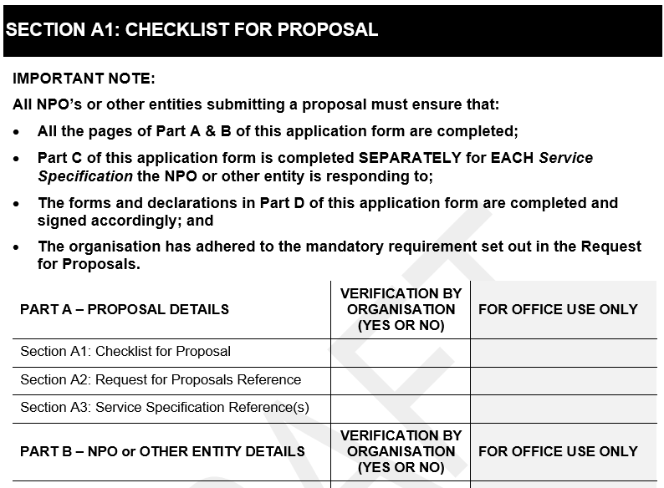

The second table in this section lists each of the required supporting documentation. It is essential that the applicant includes all the supporting documentation required of them and that each document is checked off in this list. Similarly, to the first table, mark either yes or no, under the “Verification by Organisation (Yes or No)” column, for each item.

Note that some supporting documentation may not be relevant to all organisations and these can be excluded from the application.

### Section A2: Request for Proposal Reference

Refer to the Request for Proposal Document published by the Department – the cover page contains the Title of Request for Proposal and the reference number. Use this information to complete section A2 of the application form.

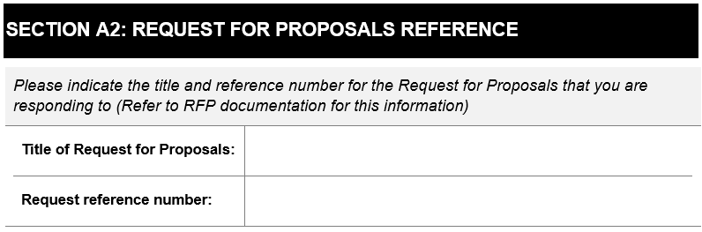

*NB: For this Call for Proposal the Title and Reference Number are:*



### Section A3: Service Specification Reference(s)

Refer to the Request for Proposal Document published by the Department – *Part B: List of Service Specifications.* Only applications for these services will be considered by the Department. Your programme may deliver on more than one of the service specifications, in which case you can apply for funding for more than one service specification that is listed in the RFP. In section A3 of the application, list all the Service specification reference numbers and the titles of the service specifications for which you are applying.

|  |  |
| --- | --- |
| Information with solid fill | **Note that an applicant may apply for more than one service specification that is requested by the Department in the Request for Proposal. Where an applicant is applying for multiple service specifications, one application form can be submitted; however, Part C of the application form must be completed separately for each service specification that the applicant is responding to. For example, if the applicant is applying for two service specifications – they would complete Part A and Part B once and attach two versions of Part C to the application, one for each service specification.** |

## Part B - NPO or Other Entity Details

### Section B1 NPO or other entity details

The purpose of this section is to capture the general details of the organisation. In completing this section of the application, it will be important to make use of the organisations’ registration papers as a resource to complete this section of the application form.

All entity details should be the same as those that are displayed on the organisations’ certificate of registration. If the details on the certificate of registration are incorrect they need to be updated with the relevant authority.

Section B1.1

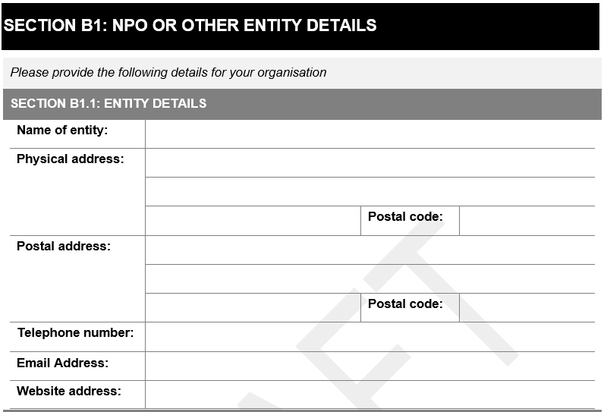

*Name of entity:* The name of entity will be the name that will be used on the service level agreement (SLA), should one be entered into with the applicant. Please ensure that this name matches with that on the organisations registration document.

*Physical address:* If the organisation operates from more than one physical address, the physical address at which the administrative functions of the organisation take place or the primary service functions provided by the organisation take place should be used.

*Postal address:* The postal address may be the same as the physical address. However, the organisation should ensure that the post can be reliably delivered to this address.

*Telephone number:* This should be the primary telephone number used for the organisation.

*Email address:* This should be the primary email address used for the organisation.

*Website address:* Provide a website address for the organisation if one is available.

Section B1.2

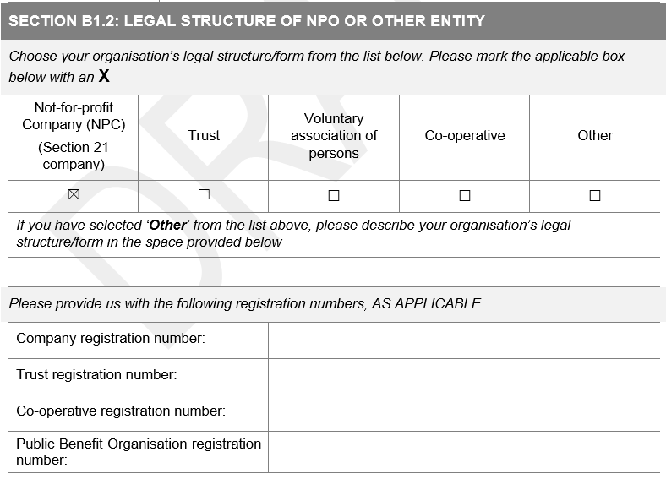

Select the relevant legal structure of the applicant organisation. If the legal structure of the organisation is not listed, select “Other” and describe the legal nature of the organisation in the space provided.

Based on the selection in the first part of section 5.2, provide the relevant registration numbers for the organisation.

### Section B2: NPO Registration Details

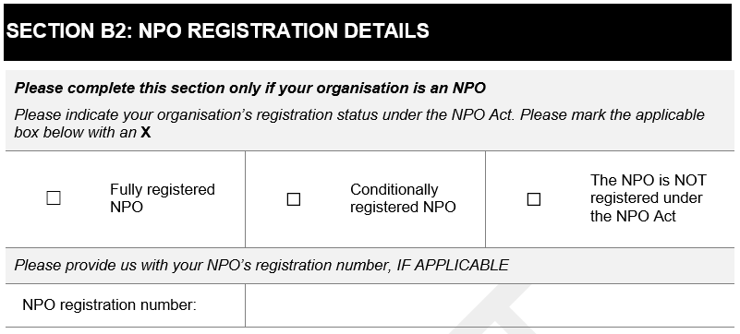

Section B2 should only be completed by applicants that are NPOs. If the applicant organisation is not an NPO, skip to section B3 of the application form.

Mark the relevant registration status. Ensure that the applicant has the relevant documentation to support the selected status.

Provide the NPO registration number as it is provided on the organisations registration certificate.

### Section B3: Contact persons for NPO or other entity

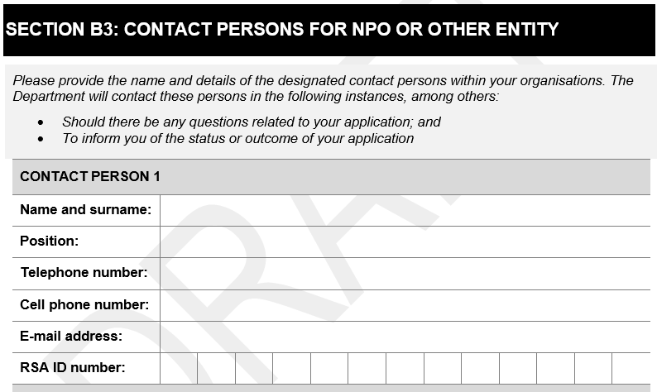

Provide the details for at least two contact persons, with whom the Department can make contact during the application process. These individuals should be able to provide comprehensive responses to questions related to the application and the organisation in general.

### Section B4: Authorised signatory of NPO or other entity

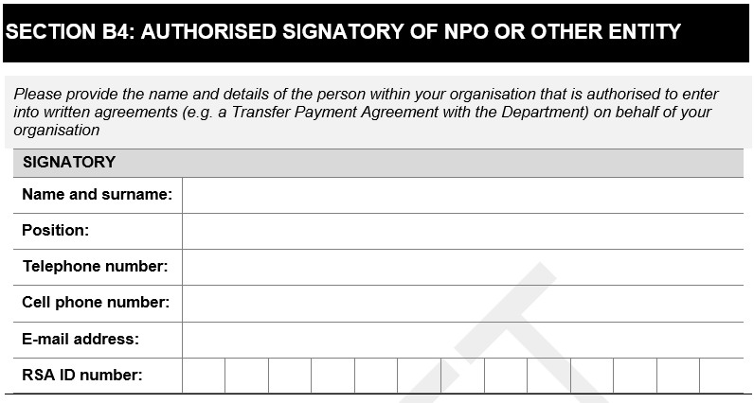

The details of the signatory for the organisation must be listed in this section of the application form.

The signatory listed in the application will be required to sign any transfer payment agreement (TPA) with the DSD, should the organisation enter into one.

In completing this section of the application, it would be advantageous to consult with an individual involved in the general management or financial management of the organisation.

### Section B5: Governance practices of NPO or other entity

#### Section B5.1 – Type of Governing Body

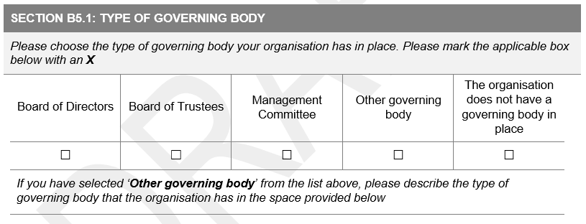

Mark the relevant type of governing body that the applicant organisation has in place.

If the applicant selects “Other governing body”, describe the type of governing body in the space provided.

#### Section B5.2 – Composition of Governing Body

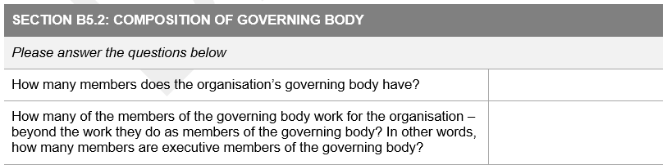

Provide the number of persons who are on the governing body of the applicant organisation.

The second question asks for the number of persons on the governing body, who also perform work for the organisation beyond their role as a member of the governing body. This includes people who are employed by the organisation or volunteer to do work for the organisation.

#### Section B5.3 – Meetings of the Governing Body

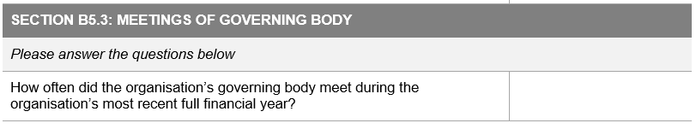

In section B5.3, document the number of times the governing body has met during the most recent full financial year. These meetings may include meetings held physically and virtually – however, they must be considered official meetings of the governing body.

Mark the relevant box regarding the taking of minutes during the governing body meetings. Please note that the minutes of these meetings may be requested by the Department if deemed necessary.

### Section B6: Composition of Board or Management Committee

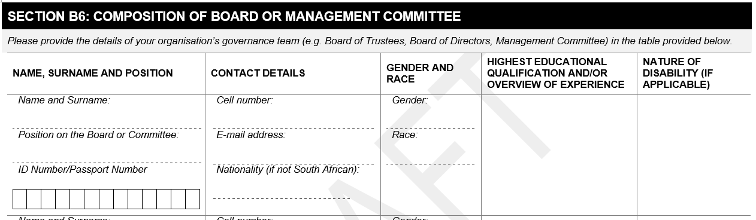

The details of the board or management committee should be filled into the table provided in the application form. If the application form does not provide sufficient space for the number of members on the organisations’ board, please add additional pages as necessary.

In completing this section of the application, it would be advantageous to consult with the organisations’ management or an individual responsible for human resources in the organisation.

The name and surname should be documented as per the individuals’ ID book or passport.

Where a member is not a South African Citizen, please use their passport number in place of an ID number and note their nationality in the block alongside the passport number.

The information on gender, race and disability is collected for statistical purposes and to contribute towards the monitoring of DSD’s progress towards their transformation goals.

* For gender, please select the gender of an individual based on how that individual identifies.
* For race, in South Africa, the population is commonly divided into Black, Coloured, Asian and White. If an individual does not identify with any of these four races, please specify clearly the race of that individual.

### Section B7: Financial Matters of NPO or other entity

#### Section B7.1 – Financial management arrangements

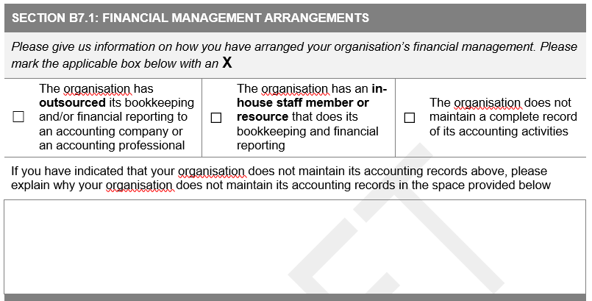

Mark the applicable box as it pertains to the financial management arrangements of the organisation.

* If the organisation has an external organisation or individual maintaining their bookkeeping and/or financial reporting, select the first option of **outsourced** bookkeeping and/or financial reporting. I.e. the maintenance of the organisations accounting functions is NOT done by an individual employed by the organisation. The external accounting provider may or may not be remunerated for their services.
* If the organisation has a member of staff who maintains their bookkeeping and/or financial reporting, select the second option of **in-house staff member or resource**. I.e. the maintenance of the organisations accounting functions is done by an individual who is employed by the organisation. The internal resource is remunerated for their services.
* If the organisation does not maintain a complete record of its accounting activities, the last option should be selected. If this option is selected, provide an explanation of why this is the case in the space provided.

#### Section B7.2 – Details of individuals responsible for financial management

In section B7.2, the applicant is required to provide the details of the individual or organisation that is responsible for the bookkeeping or financial management of the applicants’ organisation.

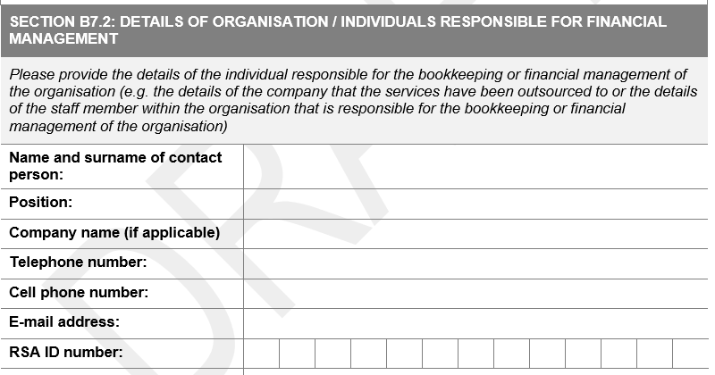

* The company name is only relevant if there is an external organisation providing the bookkeeping or financial management services to the applicant.

In completing this section of the application, it would be advantageous to consult with the financial organisation providing the service (in the case of outsourcing) or with human resource records (in the case of an internal resource).

#### Section B7.3 – Size of NPO or other entity

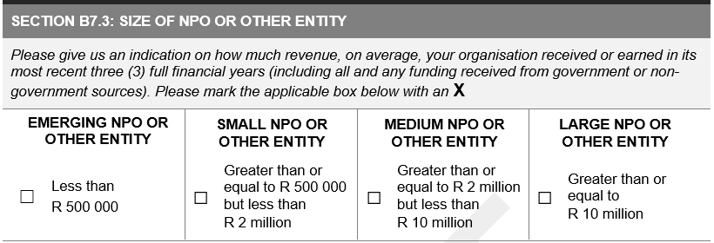

To determine the size of the applicant organisation, indicate, based on how much revenue the organisation received or earned in its most recent full financial year, the size of the organisation.

In order to determine the revenue of the organisation:

* Use the most recent Annual Financial Statements or Income and expenditure statement (see Form 1 in Part D of the application form)
* Where the organisation has an Annual financial statement, use the amount indicated as **REVENUE.**
* Where the organisation has an Income and Expenditure Statement, use the amount indicated as **INCOME.**

Based on the size of the organisation, include in the application the relevant financial statements as listed in the table included in Section B7.3 (see below).

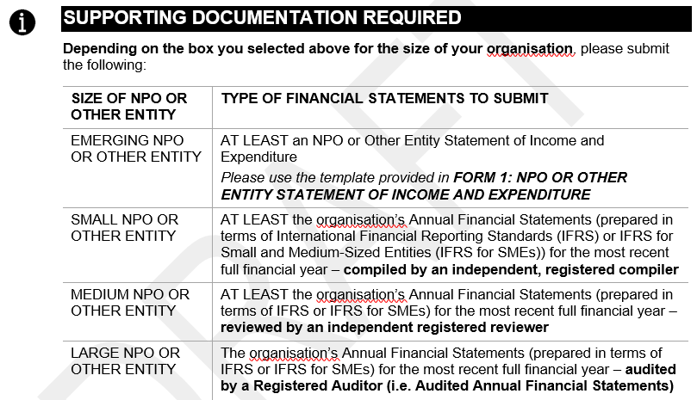

#### Section B7.4

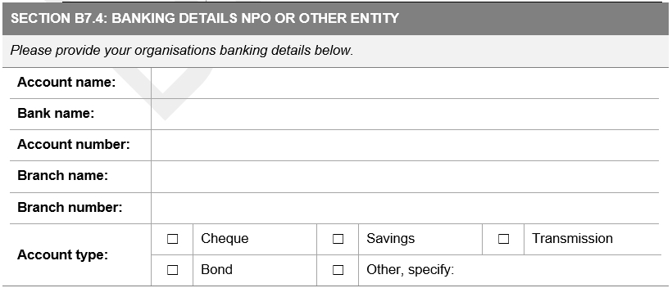

Provide the banking details for the applicant organisation in Section B7.4 as they are required.

* Account name – the account MUST be in the name of the NPO or other entity. No third party payments are allowed.
* Bank Name
* Account number
* Branch name
* Branch number
* Account type – select the relevant option or specify if ‘other’ is selected

The Department requires supporting documentation in relation to the applicants’ banking details. Acceptable supporting documentation constitutes:

* ***FORM 3: DECLARATION OF NPO OR OTHER ENTITY BANK ACCOUNT DETAILS*** – signed and stamped by the relevant banking institution – confirming the details of the bank account (the declaration must be dated less than three (3) months from the closing date for submitting the proposals)

OR

* A **stamped confirmation letter** from the relevant banking institution – detailing:
  + The name of the NPO or other entity;
  + The banking details of the NPO or other entity;
  + The company registration number, if applicable; and
  + The fact that the bank account is active.

The confirmation letter must be dated less than three (3) months from the closing date for submitting the proposals.

### Section B8: Transformation

Transformation is a critical component of the Departments service provision. This includes transformation within the organsiations that they partner with to provide the required services, as well as transformation of the social development sector broadly.

Section B8.1

In the first part of section B8, provide details related to the transformation of the applicant organisation. Provide details of how the applicant organisation currently is contributing towards transformation AND then how the applicant organisation intends or further improving transformation with the organisation. This includes transformation of staff within the entity to ensure adequate representation of various ethnic groups, abilities and gender.

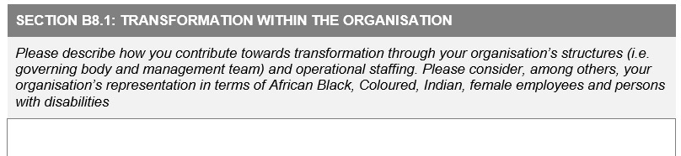

Section B8.2

The second part of Section B8 requires details related to the applicant organisations’ transformation efforts within the social development sector more generally. Describe how the applicant organisation currently contributes towards transformation in the sector and how they intend on further contributing towards it in the future.

Consider how the organisation is making an effort to reach the most vulnerable populations, including those in areas where services are scarce.

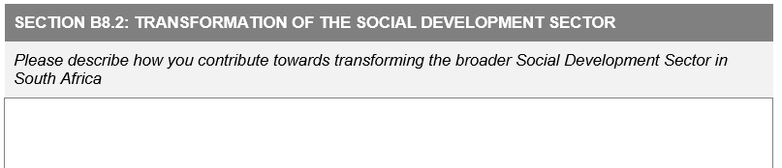

Section B9: Declaration by NPO or other Entity

The final section of Part B of the application form is the declaration by the NPO or other entity. Before completing the declaration section of the application form – the form should be reviewed by relevant individuals in the organisation for accuracy and completeness. It is important to ensure that the application is a reflection of the organisation and not any single person who completed it.

The declaration should be signed by an individual within the organisation with the authority to do so.

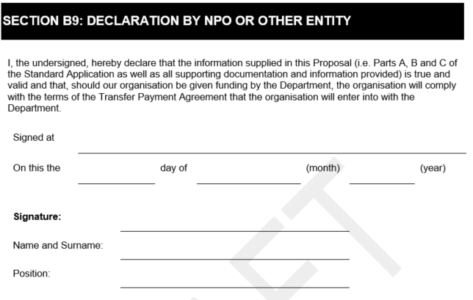

When completing Section B9:

* Signed at *<insert the name of the town in which the document is being signed>*
* Insert day of the month followed by the name of the month (i.e. written in words not numbers e.g. January; not 01) and the year.
* The signatory should sign their FULL signature and NOT just their initials or a shortened version of their signature.
* The full name and surname of the signatory should be provided. Do not fill in only the initials and the surname.
* Provide the position or designation of the individual signing the application as it is identified by the organisation.

## Part C – Plan for Project, Programme or Other Intervention

In Part C of the application, the Department would like for the applicant to provide a detailed plan of the project, programme or other intervention that will be offered with the funding provided by DSD. This is likely to be the Part of the application that will take the longest to complete. The applicant is encouraged to take time to complete it fully and accurately. A clear description of the project, programme or other service being offered will ensure that the DSD has sufficient information to adjudicate the application.

### Section C1: Service Specification Reference

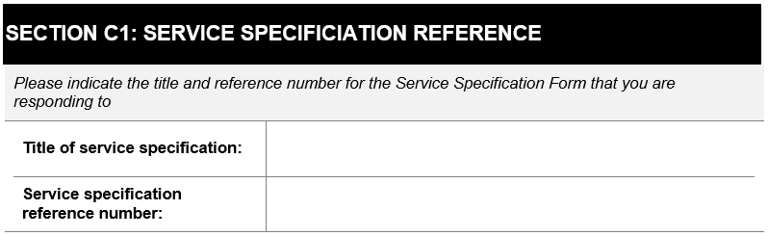

Provide the title and the reference number of the service specification relevant to this part of the application. Note that if the applicant is applying for funding for more than one service specification, Part C of the application needs to be completed for each service specification being applied for.

### Section C2: Description of Project, programme or other intervention

In completing this section of the application, it would be advantageous to consult with the individual/s responsible for the design and implementation of services, programmes and projects in the organisation.

#### Section C2.1 – Description of project, programme or other intervention and its components

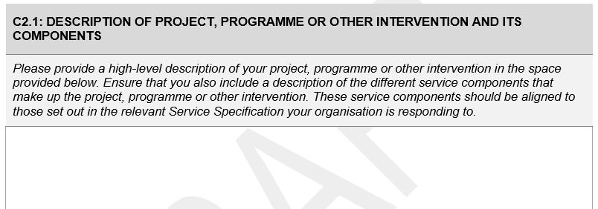

The first part of section C calls for a description of the service, project or programme that the applicant will be providing with the DSD funding. Provide a high level description of the project, programme or other intervention, as it is related to the service specification, without repeating what will be included in the rest of this section (i.e. beneficiaries, location and activities).

The applicant should include a description of the different service components of their project, programme or other intervention, as they are set out in the relevant service specification.

Please note, this section must be completed. Referring the reader to a section of the organisations constitution or other attachment is not adequate. The application will be considered incomplete and sent back to the organisation if this is done.

|  |  |
| --- | --- |
| info-icon - Montgomery Planning | **TIP!**  **Consult with the service specifications to determine what the expectations are with regards to services, their objectives and expected outcomes. This will help to highlight how the organisations’ project, programme or other intervention, in particular, will contribute towards the achieving the objectives and expected outcomes of services for the DSD.**  **(However, if the applicants’ services have benefits beyond these, ensure that those are included as well)** |

#### Section C2.2 – Target beneficiaries and service users

The second part of section C requires details about the target beneficiaries and service users of the project, programme or other intervention. The table requires the applicant to list the category of beneficiary, the number of beneficiaries that will benefit, and how they will benefit from the project, programme or other intervention.

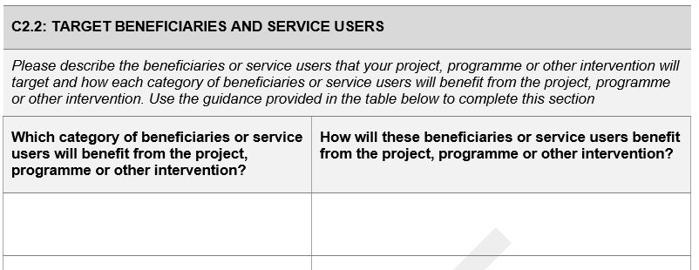

When listing the category of beneficiaries that will benefit from the project, programme or other intervention, provide list of beneficiaries to complete the table.

Provide a description of how each of the beneficiaries would benefit from the project, programme or other intervention in the second column of the table.

#### Section C2.3 – Geographic coverage or location

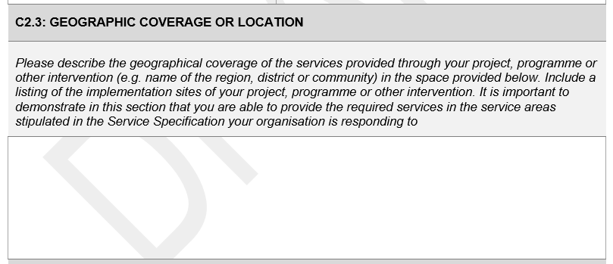

Outline where the project, programme or other intervention that the applicant organisation will be implementing will be geographically. Provide details such as the name of the districts and towns in which the service, programme or project will be implemented.

It would also be valuable to describe the area in terms of settlement type. Describe the area as urban or rural; a township, farming area, suburban area; an informal settlement or other relevant descriptors. The applicant may also provide additional information, regarding the accessibility of the area or the nature of service provision in the area (e.g. healthcare services, refuse removal etc.).

The needs for services vary across different geographic areas and settlement types. Describing the geographic area in the application for funding allows for the Department to understand the potential need for services in those areas.

#### Section C2.4 – Time-related elements of your project, programme or other intervention

In this final part of Section C, consider any time related elements of the project, programme or other intervention. These time related elements may impact on when implementation may occur.

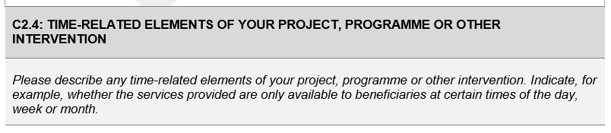

Consider the following time related elements:

* Time of day (morning, afternoon, evening)
* Time of week (week, weekend)
* Time of month (possibly related to pay-day)
* Seasonal (related to temperature, daylight hours, seasonal work hours)
* School calendars (school holidays)
* Public holidays and commemorative events (public holidays, religious holidays, awareness days etc.)

### Section C3: Implementation plan for project, programme or other intervention

In this section of the application form, the applicant should provide details about HOW they will implement their project, programme or other intervention. Applicants should provide sufficient detail to ensure that the Department has an adequate understanding of how their project, programme or other intervention will be implemented in order to deliver on the service specification being dealt with.

#### Section C3.1 – Activities and expected results of project, programme or other intervention

Using the table provided, describe the nature of the activities and the expected results of the project, programme or other intervention for which the applicant is requesting funding. It is only necessary to describe the activities related to the specific service, programme or project for which the applicant is applying for funding. It is not necessary to describe ALL the activities performed by the organisation if they are not ALL related to this specific service specification.

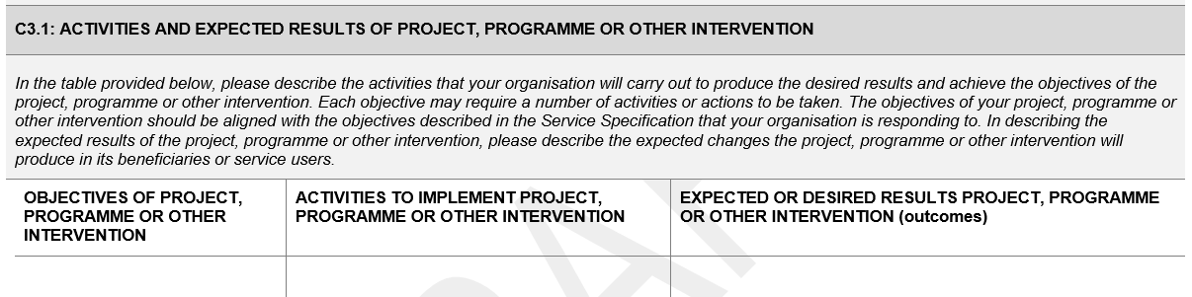

In the table, list each of the objectives of the project, programme or other intervention, the related activities which help to achieve that objective and then the expected or desired results related to those activities.

The applicant may add additional pages for this section as required.

#### Section C3.2 – Activities and expected results of project, programme or other intervention

In this section, the applicant should provide information related to the measurement of progress and performance of the project, programme or other intervention.

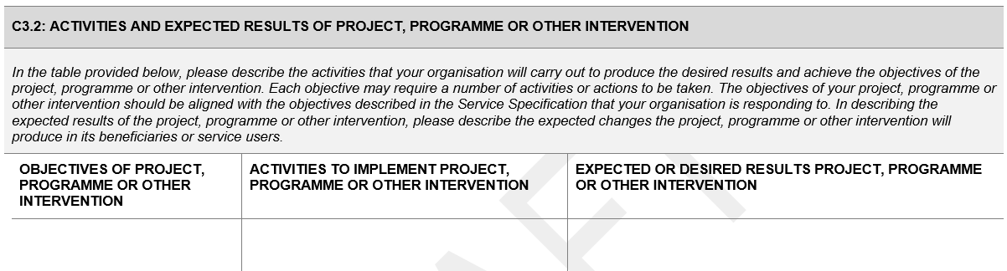

In the first column, list the names of the indicators most useful to measure the progress or performance of the project, programme or intervention. For the indicators, consider input, output and outcome indicators.

|  |  |  |  |  |  |  |
| --- | --- | --- | --- | --- | --- | --- |
| **Inputs**  What are the things I need to carry out the activities? |  | **ACTIVITIES** |  | **Outputs**  What are the direct outputs of performing the activities? |  | **Outcomes**  What are the resultant changes from performing the activities? |

In the second column, provide an indication of the target that the organisation intends to achieve for that indicator. It is important that these targets are informed by previous experience or relevant research to ensure that they are accurate and realistic.

#### Section C3.3 – Indicators and targets for Project, programme or other intervention

In the table provided, list the indicators to measure the progress and performance of the programme in relation to the service specification being dealt with. When listing the indicators, ensure that they are SMART indicators. The definition of SMART indicators is provided below:

|  |  |  |
| --- | --- | --- |
| S | Specific | The indicator must be narrow and accurately describe what needs to be measured. |
| M | Measurable | You must be ABLE to measure the indicator i.e. it can be counted, observed, analysed, tested or challenged. |
| A | Achievable | Is the indicator achievable through the programme and is the target attached to the indicator achievable (realistic). |
| R | Relevant | Is the indicator relevant to the project, programme or intervention? Can the indicator measures be linked to the theories underpinning the programme? |
| T | Time-bound | Indicators must have a component of time. |

### Section C4: Staffing plan for project, programme or other intervention

The table in section C4 needs to be completed with the requested details of ALL individuals working for the organisation at the time of completing the application. The purpose of this table is to determine the range of expertise and skills accessible to the NPO and to document demographic and transformational statistics.

Please note that ALL staff working for the organisation must be documented here, even if they do not have any involvement in the programme or service for which funding is being requested.

In completing this section of the application, it would be advantageous to consult with the individual/s responsible for the management of human resources in the organisation.

The applicant may include additional pages as required.

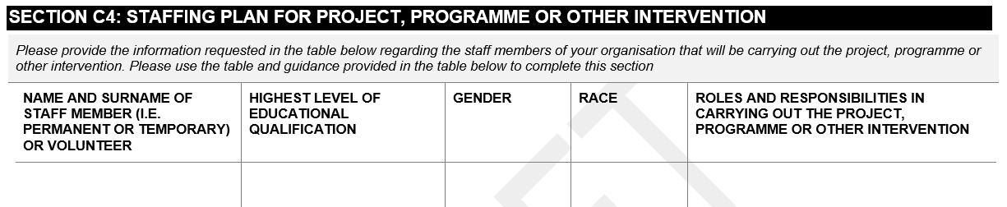

### Section C5: Previous experience carrying out the same or similar projects, programmes or other interventions

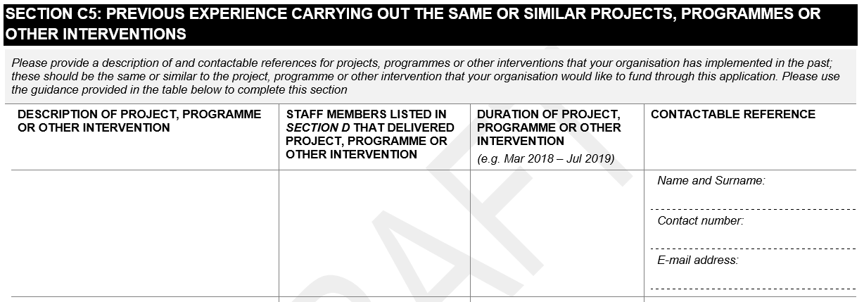

Section C5 is intended to gain an understanding of the applicant organisations’ previous experience in offering the project, programme or other intervention that they are requesting funding for.

In completing this section of the application, it would be advantageous to consult with the individual/s responsible for the design and implementation of projects, programmes and other interventions in the organisation. Individuals within the organisation who have been there the longest will be able to provide institutional memory which will also be valuable to this section of the application form.

* Provide a description of the project, programme or other interventions that the organisation has provided previously that are RELEVANT to the service specification in this particular application.
* List the persons, included in Section C4 of the application, that were involved in the previous project, programme or other intervention.
* Indicate the duration of the programme.
* The contactable reference person should be an individual who the Department can contact as a reference for the applicant organisation.
  + If the project, programme or other intervention that the applicant offered was for another organisation – the reference person would be the individual who was in charge of the programme on behalf of that organisation.
  + If the project, programme or other intervention was funded by a particular entity, the reference person would be the individual who was responsible for managing the applicant organisation on behalf of the funding organisation.

Ensure that the contact details provided are correct. It is also advisable to ensure that the reference person listed is aware that they have been listed as a reference.

### Section C6: Budget for project, programme or other intervention

This section will provide DSD with an idea of the applicants expected expenditure in implementing the project, programme or intervention for which funding is being requested. In completing this section of the application, it would be advantageous to consult with individual’s responsible for the financial management of the project, programme or intervention.

#### Section C6.1 – Duration of funding for project, programme or other intervention

In section C6.1, provide the duration of funding that is required for the project, programme or intervention.

Please consider that the Department can offer an agreement for a maximum of three years, which may be extended based on the performance of the organisation in implementing the project, programme or intervention.

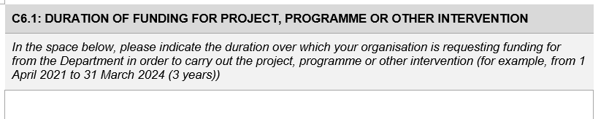

#### Section C6.2 – Operational budget for project, programme or other intervention

Each budget item should be listed in the table provided together with the expected amount in rands, each year for three years. This budget is specific to the project, programme or intervention for which funding is being requested in this application. Expenditure related to other services, programmes or projects should not be included in this application.

Ensure that the figures included in this budget are as accurate a reflection as possible of the expenditure for the service, programme or project. Annual inflation should be reflected in the figures across the three years.

Total each row and each column of the table. I.e. there should be a total for each budget item for all three years and there should be a total for each year of all the budget items. Also ensure that the totals of both the rows and columns add up to the grand total.

Keep in mind that the DSD funds organisation to provide services based on a minimum funding standard. Therefore, it is unlikely that DSD will fund the exact amount documented in this budget. However, it is important for DSD to have an understanding of what the expectations are in terms of expenditure.

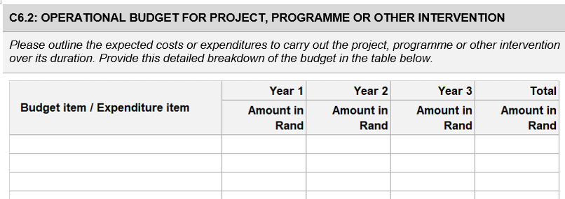

Section C6.3 – Narrative for operational budget

Please provide a narrative for the operational budget in the space provided in Section C6.3. The narrative can be at a high level. Focus on the main costs included in the budget. Also include explanations for significant changes in costs from one year to the next.

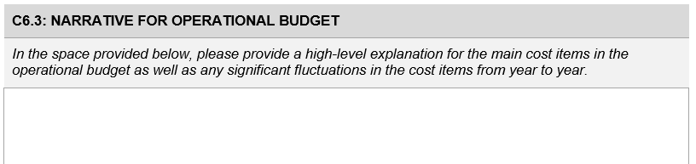

### Section C7: Funding request for project, programme or other intervention

In section C7, include the total funding that is being requested for each year that the organisation is requesting funding.

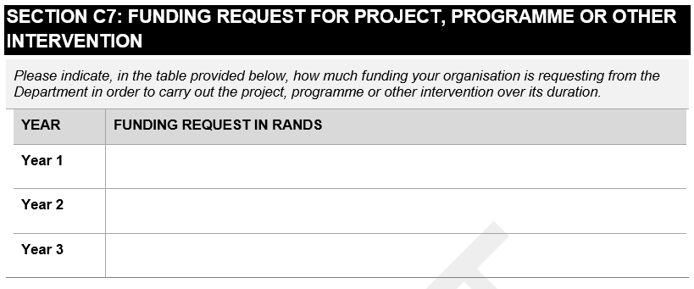

## Part D – Forms and Declarations

Part D of the application form includes all the forms and declarations which are required to complete the application form. Ensure that these templates are used as requested throughout the application form.

### Form 1: NPO or other entity statement of income and expenditure

Form 1 is the template for the Statement of Income and Expenditure. This template should only be used by emerging entities who do not have audited financial statements available to submit with the application.

This form should be completed by the person responsible for managing the financial affairs of the organisation.

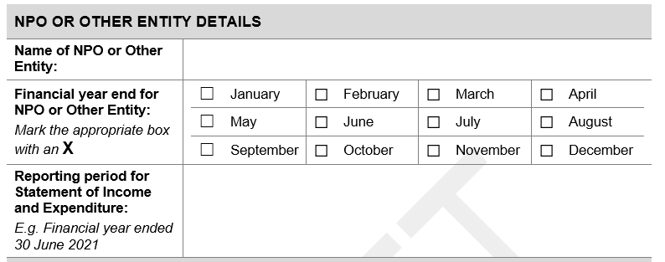

The first part of the statement of income and expenditure requires:

* the name of applicant organisation – ensure that the name matches that used on the organisations’ registration documents;
* the financial year end for the NPO or other entity – mark the appropriate box with an X. Note that only one month should be selected as the year end;
* the reporting period for the statement of income and expenditure. Indicate a starting date and end date for the reporting period.

In the next table all the funds that have been received during the reporting period should be listed. This includes incomes generated by the organisation, donations and funds received from funding institutions (e.g. banking institutions, government departments (including DSD), other funding institutions e.g. Lottery).

Provide a total amount received at the bottom of the second column – TOTAL FUNDS RECEIVED (A).

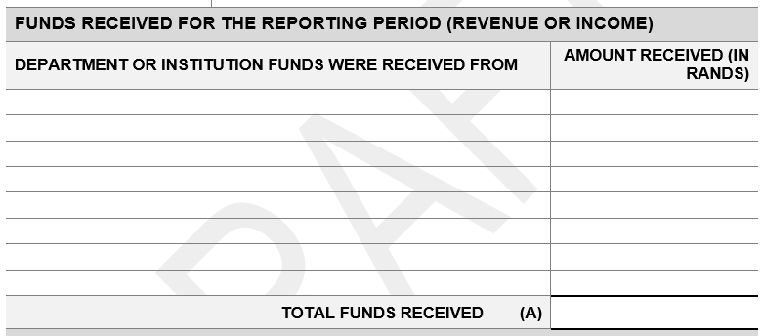

The following table requires a list of the payments made during the reporting period. In the first column the type of expenditure should be listed (e.g. water and electricity, rent, groceries etc.). In the second column, the total amount spent on that particular expense for the reporting period should be listed.

Provide a total amount paid at the bottom of the second column – TOTAL FUNDS PAID (B).

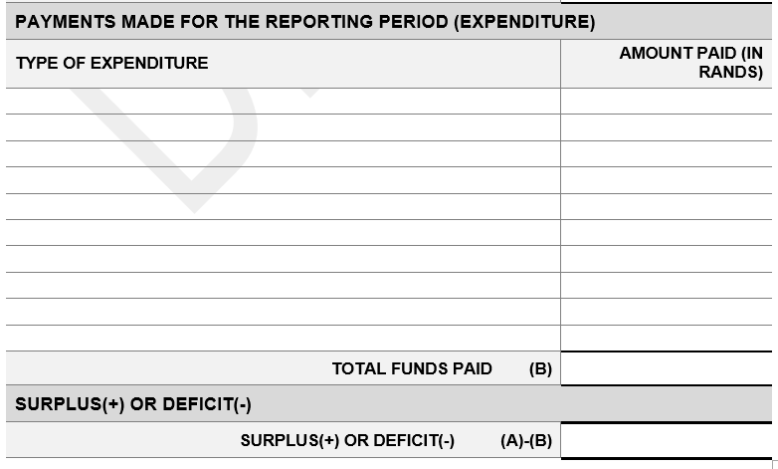

Beneath the list of expenditures, calculate the difference between the Total funds received and the total funds paid (A)-(B). If the funds received are more than those paid, then the amount will be a positive number (i.e. a surplus). If the funds received are less than those paid, then the amount will be a negative number (i.e. a deficit).

In the space provided, elaborate, explain and or provide further information which can clarify the contents of the Statement of Income and Expenditure.

The final part of the Statement of Income and Expenditure requires for an individual with the relevant authority within the applicant organisation to confirm that the information provided in the Statement of Income and Expenditure is true and correct.

The declaration should be completed as follows:

* Signed at *<insert the name of the town in which the document is being signed>*
* Insert day of the month followed by the name of the month (i.e. written in words not numbers e.g. January; not 01) and the year.
* The signatory should sign their FULL signature and NOT just their initials or a shortened version of their signature.
* The full name and surname of the signatory should be provided. Do not fill in only the initials and the surname.
* Provide the position or designation of the individual signing the application as it is identified by the organisation.

### Form 2: NPO or other entity declaration regarding financial management and internal control systems

In terms of section 38(1)(j) of the Public Finance Management Act (PFMA), the Department of Social Development (the Department) requires written assurance that an organisation implements effective, efficient and transparent financial management and internal control systems. Form 2 is the declaration template that should be used by all organisations submitting a funding application.

**Parts A and B** should be completed by those NPOs or other entities that implement effective, efficient and transparent financial management and internal control systems.

**Parts A and C** should be completed by those NPOs or other entities that **DO NOT** implement effective, efficient and transparent financial management and internal control systems.

Part A is made up of two sections. The first section requires the general organisation details as was done in the application form. The information required includes:

* Name of entity
* Physical address
* Postal address
* Telephone number
* Cell phone number
* Email address
* Contact person

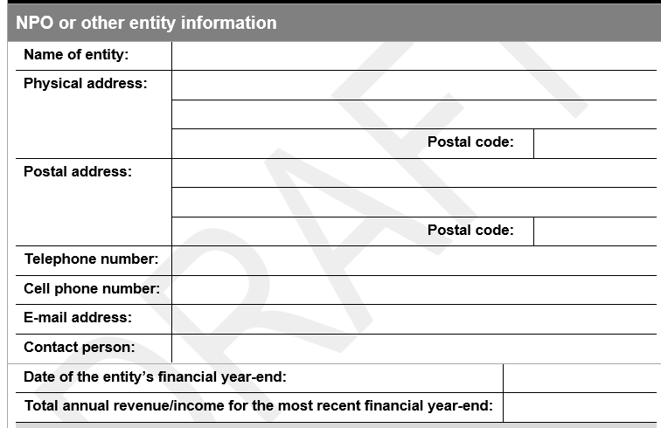

The second section is required to be completed and stamped by the bank. The information that is required includes:

* Date of the entity’s financial year-end
* Total annual revenue/income for the most recent financial year-end

In the next part of the table, select which size category the organisation falls into. This size category is based on the total annual revenue. Place an X in the relevant box (only one box should be marked).

In order to determine the revenue of the organisation:

* Use the most recent Annual Financial Statements or Income and expenditure statement
* Where the organisation has an Annual financial statement, use the amount indicated as **REVENUE.**
* Where the organisation has an Income and Expenditure Statement, use the amount indicated as **INCOME.**

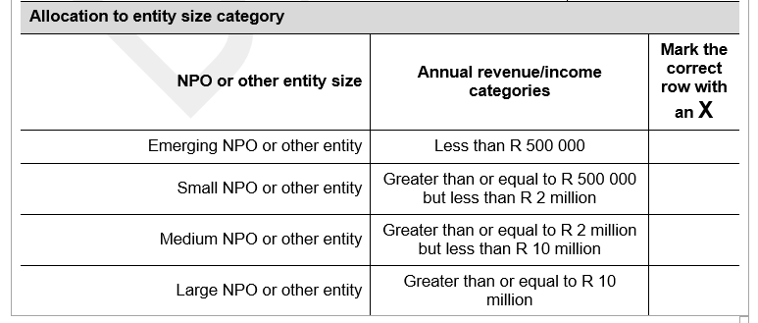

**Part B** should be completed by those NPOs or other entities that implement effective, efficient and transparent financial management and internal control systems. This part of the document is the actual declaration and must be signed by a person of authority. It must also be witnessed by two independent individuals.

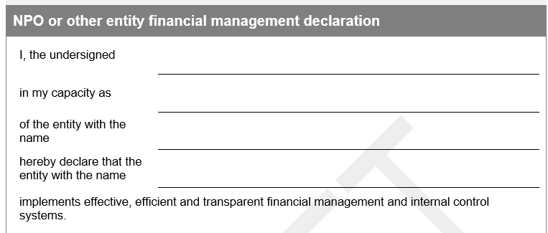

The declaration should be completed as follows:

|  |  |
| --- | --- |
| I, the undersigned | *<insert the signatories’ full name and surname>* |
| In my capacity as | *<insert the signatories’ role or designation within the organisation>* |
| Of the entity with the name | *<insert the name of the organisation as per the registration documents>* |
| Hereby declare that the entity with the name | *<insert the name of the organisation as per the registration documents>* |
| Implements effective, efficient and transparent financial management and internal control systems. | |
| Signed at | *<insert name of town where the declaration is being signed>* |
| On this the *<insert date>* day of *<insert month in words>* (month) *<insert year>* (year) | |
| Signature | *Signatory should sign their full signature, not a shortened version of their signature, nor just their initials.* |
| Witness 1 | *The witness should write their full name and surname and sign their full signature, not a shortened version of their signature, nor just their initials.* |
| Witness 2 | *A second witness should write their full name and surname and sign their full signature, not a shortened version of their signature, nor just their initials.* |

**Part C** should be completed by those NPOs or other entities that **DO NOT** implement effective, efficient and transparent financial management and internal control systems.

In instances where written assurance cannot be obtained that effective, efficient and transparent financial management and internal control systems are implemented, s 38(1)(j) of the PFMA requires that the transfer must be subject to conditions and remedial measures requiring the entity to establish and implement such systems. The following conditions and remedial measures, therefore, will apply:

* Management will implement and adhere to the financial control system prescribed by the Department to maintain its financial records.
* Management will subject itself to the monitoring and inspection of financial records on a regular basis as conducted by officials of the Department or its representatives.
* Management will submit the financial expenditure reports and financial statements required by the Department.

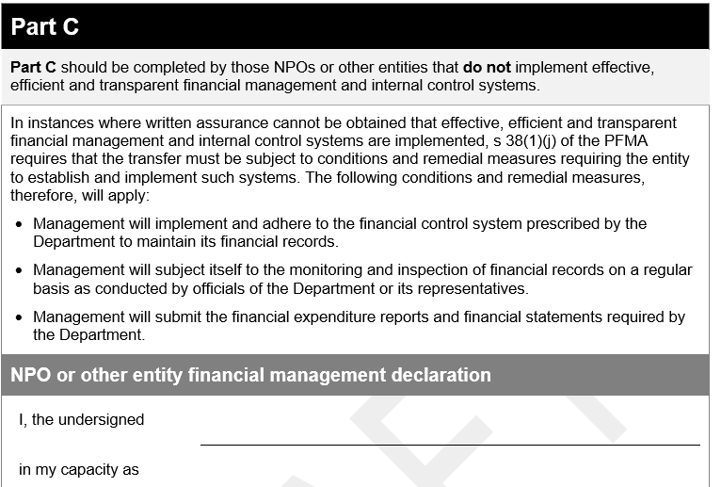

The declaration should be completed as follows:

|  |  |
| --- | --- |
| I, the undersigned | *<insert the signatories’ full name and surname>* |
| In my capacity as | *<insert the signatories’ role or designation within the organisation>* |
| Of the entity with the name | *<insert the name of the organisation as per the registration documents>* |
| Hereby declare that the entity with the name | *<insert the name of the organisation as per the registration documents>* |
| will adhere to the conditions as stipulated above in order to ensure effective, efficient and transparent financial management and internal control systems. | |
| Signed at | *<insert name of town where the declaration is being signed>* |
| On this the *<insert date>* day of *<insert month in words>* (month) *<insert year>* (year) | |
| Signature | *Signatory should sign their full signature, not a shortened version of their signature, nor just their initials.* |
| Witness 1 | *The witness should write their full name and surname and sign their full signature, not a shortened version of their signature, nor just their initials.* |
| Witness 2 | *A second witness should write their full name and surname and sign their full signature, not a shortened version of their signature, nor just their initials.* |

### Form 3: Declaration of NPO or other entity bank account details

Each organisation that submits an application for funding to the DSD is required to submit a declaration of bank account details. Form 3 serves as the template the applicant organisation can use for the declaration.

The declaration is divided into three sections:

Section 1: NPO or other entity banking details

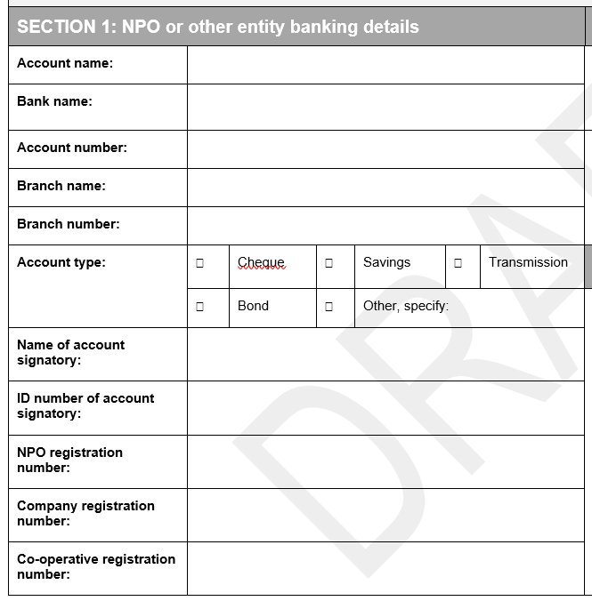

* Account name – the account MUST be in the name of the NPO or other entity. No third party payments are allowed.
* Bank Name
* Account number
* Branch name
* Branch number
* Account type – select the relevant option
* Name of account signatory – if there is more than one account signatory, please include the details of all signatories
* ID number of signatories
* NPO registration number – as per the organisations NPO registration certificate (if applicable)
* Company registration number - as per the organisations company registration certificate (if applicable)
* Co-operative registration number - as per the organisations registration certificate (if applicable)

Section 2: Confirmation by bank

This form must be taken to the organisations’ bank to be stamped and signed. The bank official must stamp the form with the official bank stamp and provide their details in the space provided.

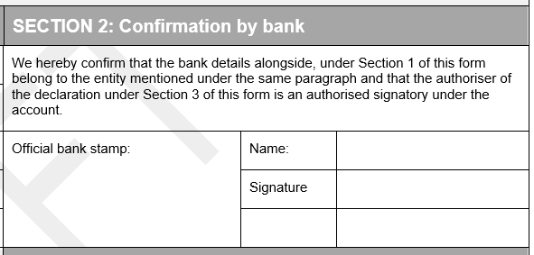

Section 3: NPO or other entity declaration

The entity declaration should be signed by a person with the authority to do so from the applicant organisation.

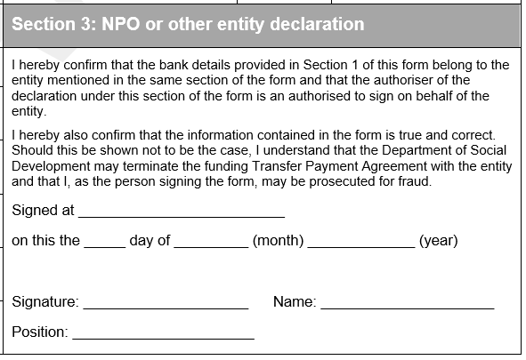

The declaration should be read carefully by the signatory before being completed as follows:

|  |  |
| --- | --- |
| Signed at | *<insert name of town where the declaration is being signed>* |
| On this the *<insert date>* day of *<insert month in words>* (month) *<insert year>* (year) | |
| Signature | *Signatory should sign their full signature, not a shortened version of their signature, nor just their initials.* |
| Name | *Full name and surname of the signatory* |
| Position | *Role or designation of the signatory in the organisation* |